1. **Write a program to perform Prim ‘s Algorithm with all its intermediate output.**

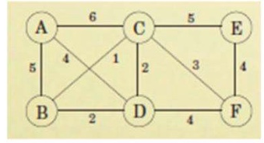

1. **Write a program to perform Kruskal’s Algorithm with all its intermediate output.**



1. **Write a program to give all the possible spanning tree solution for the below given graph.**

